
STATE OF ISRAEL

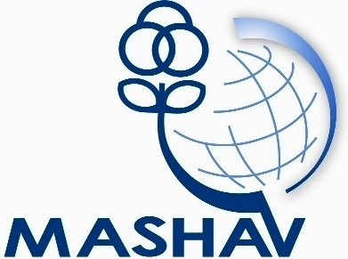

Israel’s Agency for International Development Cooperation
Ministry of Foreign Affairs

CINADCO
Center for International Agricultural Development Cooperation
Ministry of Agriculture and Rural Development
International Course on:
Plastics in Agriculture –
Innovations & Applications

8- 21 May, 2012

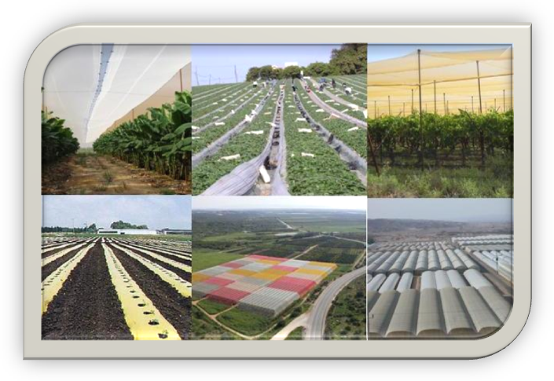

MASHAV – Israel’s Agency for International Development
Cooperation, CINADCO - Center for International Agricultural
Development Cooperation, invite professionals from the Agriculture Extension Agent, Agriculture Development Officers, Researchers and Academics to participate in the course on:
Plastics in Agriculture – Innovations & Applications
which will take place at CINADCO's training center, Israel
8-21 May, 2012




About the Course
Background

Modern agriculture is based on a wide spectrum of plastic products. From irrigation systems through greenhouse technologies, protective nettings, soil covers, plastics for animal husbandry, food packaging, and more. The level of sophistication in both the production and uses of plastics in agriculture is increasing continuously, based on the huge scientific progress made during the last few decades in plastics chemistry as well as plant and animal sciences.
The innovations in plasticulture are translated into practices that support agriculture around the globe, for improving the production, quality and food safety. Special effort is put into adapting and disseminating advanced plasticulture approaches in both developed and developing countries. The new products and technologies are targeted toward different types of growers, from large commercial companies all the way to the small private farmers.
The increased awareness of the environment and human well being has led to market demands for eco-friendly agriculture. Plasticulture is developing along this line, including plastics applications for substituting harmful chemicals, degradable products and plastics recycling.

Aims
The Course aims to share Israel’s experience and research, taking into consideration the adaptability of methods and technologies, to meet local conditions in each participant's country. After completion of this course it is envisaged that the participant will be able to understand, and as a result implement the potential of using plastics in:

- Horticulture
- Post Harvest
- Plant protection
- Irrigation

The Program
The course will include professional lectures and visits on the following subjects:

- Israel’s agriculture
- Protected agriculture
- Innovations in Plastic Covers for Agriculture
- Plasticulture for Crop Production and Plant Protection
- Relationships between technology and quality production of fruit and vegetables
- Soil covers
- Plastics for maintaining post-harvest quality
- New Irrigation approaches
- Plasticulture in Developing Countries
- Environmentally-friendly Plasticulture
- Agriculture and the environment

The participants will also have the opportunity to participate in the International CIPA
(International Committee for Plastics in Agriculture) Conference 2012 in Tel Aviv, Israel. The Conference will be held in conjunction with the Agritech 18th International Agricultural Exhibition, in the same venue. Thus, participants will be able to attend the conference, while also visiting the exhibition. Please visit www.agritech.org.il for more details.

Criteria
The Course is geared towards professionals from developing countries involved in agriculture production. Candidates should hold an academic degree in related disciplines, and at least two years of professional work experience in related fields. Priority will be given to professional staff involved in national / regional projects, with and/or under the aegis of governmental institutions, national and/or international organizations, research institutes, universities, NGOs, etc.
A full command of English is required.

Application
Application forms and other information may be obtained at the nearest Israeli mission and at Israel's Foreign Ministry's website: http://mashav.mfa.gov.il (in Contact Us → Information and Registration). Completed application forms, including the medical form should be sent to the relevant Israeli mission and to the CINADCO Training Center in Israel until the 1st of April, 2012. Fax Nº: +972 9 959 5733 or E-mail: yuval@cinadco.co.il

General Information

Location and accommodation
The course will be held at CINADCO’s International Training Centre at Kibbutz Hotel Shefayim, situated 20 km north of Tel Aviv near the coastal city of Netanya.

Transportation
Participants will be transported from and to Ben Gurion airport, without charge, by Tal Limousine Company, which is located on the mezzanine level at the Arrivals Hall. Participants are requested not to take any other transport company.

Clothing
The course will be held during the beginning of the summer, when the weather in Israel is hot and humid. Temperatures may vary between 20°C to 30°C. It is recommended to bring appropriate clothing. Including suitable footwear for field trips and swimwear.

Insurance
All participants are medically insured by MASHAV during the course. The insurance policy does not cover the treatment of chronic or serious diseases, dental care, eyeglasses, pregnancy and specific medication taken by the participant on a regular basis. Participants are required to bring with them their usual medication. No insurance of personal belongings like money, video cameras, laptops or jewelry will be provided.

MASHAV
MASHAV – Israel’s Agency for International Development Cooperation - at Israel’s Ministry of Foreign Affairs was founded in late 1957, and is responsible for the design, coordination and implementation of the Sate of Israel’s development cooperation programs.
MASHAV concentrates on human and institutional capacity building by sharing Israel’s own development experience and expertise, imparting know-how and transferring innovative technologies and tested methodologies adaptable to developing country needs.
MASHAV’s approach is to ensure social, economic and environmental sustainable development, joining the international community's efforts to implement the Millennium Development Goals by 2015.
In events of natural disasters, MASHAV also provides humanitarian assistance and participates in reconstruction and rehabilitation efforts. http://mashav.mfa.gov.il

CINADCO
The Center for International Agricultural Development Cooperation (CINADCO) is a part of the Israel Ministry of Agriculture and Rural Development. Since 1958, CINADCO has been in charge of the International Agricultural program conducted by MASHAV in Israel and abroad. CINADCO's activities consist of: International and country “tailor-made” courses in Israel, on-the-spot courses, long- and short-term projects and advisory missions. Israeli experts have also been sent to different locations around the world to conduct projects and to share their expertise in various aspects of agricultural production, extension and project planning. http://www.cinadco.moag.gov.il/cinadco

For further information please contact:
CINADCO - Special Training Activities
Hotel Shefayim 60990, Israel
Tel: 972-9-9595734/43 Fax: 972-99595733
E-mail: yuval@cinadco.co.il
http://www.cinadco.moag.gov.il
http://mashav.mfa.gov.il

